TIME AND SPACE COMPLEXITY
10 Basic Time & Space Complexity Questions
Quick Complexity Reference
Complexity | Meaning
O(1) | Constant
O(log n) | Logarithmic
O(n) | Linear
O(n log n) | Linearithmic
O(n²) | Quadratic
O(2ⁿ) | Exponential

1. Print Every Element
Question
What is the time and space complexity?
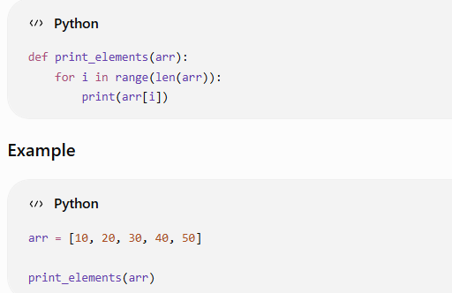
Execution
The loop runs once for every element:
10
20
30
40
50
If:
n = 5
the loop executes:
5 times
If:
n = 100
the loop executes:
100 times
If:
n = 1,000,000
the loop executes:
1,000,000 times
Therefore:
Time Complexity
O(n)
Because the number of operations grows directly with n.
Space Complexity
O(1)
We aren't creating another array or storing n elements.
Only variables such as:
i
are used.
Final
Time = O(n)
Space = O(1)

2. Access an Element
Question
What is the complexity of accessing an element from an array?
def get_element(arr):
return arr[0]
Example:
arr = [10, 20, 30, 40, 50]

print(get_element(arr))
Output:
10
Execution
Python directly accesses index 0.
It does not need to scan:
10 → 20 → 30 → 40 → 50
It directly goes to:
arr[0]
Therefore the operation takes approximately the same amount of time regardless of array size.
Even if:
n = 5
or
n = 10,000,000
the access is still direct.
Time Complexity
O(1)
Space Complexity
O(1)
Final
Time = O(1)
Space = O(1)

3. Find an Element Using Linear Search
Question
Find whether target exists in an array.
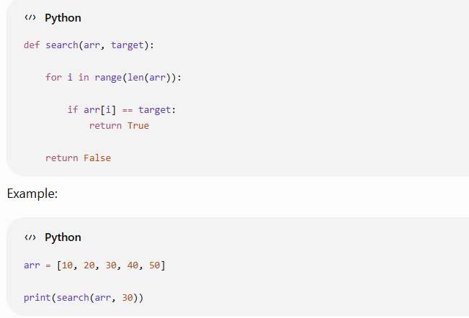
Output:
True
Execution
The program checks:
10 == 30 → No
20 == 30 → No
30 == 30 → Yes
It stops.
But consider:
search(arr, 50)
It checks:
10
20
30
40
50
And if the element doesn't exist:
search(arr, 100)
it checks every element.
Therefore, in the worst case, we perform n operations.
Time Complexity
O(n)
Space Complexity
O(1)
No additional array is created.
Final
Time = O(n)
Space = O(1)
Important
Linear search has:
Best Case = O(1)
Worst Case = O(n)
Average Case = O(n)
For Big-O interview questions, we generally discuss the worst case unless specified otherwise.

4. Two Separate Loops
Question
Find the complexity:
def example(arr):

n = len(arr)

for i in range(n):
print(arr[i])

for i in range(n):
print(arr[i])
There are two loops.
First loop:
n operations
Second loop:
n operations
Total:
n + n
Therefore:
2n
In Big-O notation, constants are ignored.
So:
O(2n)
becomes:
O(n)
Time Complexity
O(n)
Space Complexity
O(1)
Final
Time = O(n)
Space = O(1)
Important Rule
If loops are sequential:
for i in range(n):
...

for i in range(n):
...
you add them:
O(n) + O(n)
= O(2n)
= O(n)

5. Nested Loop
Question
Find the complexity:
def example(n):

for i in range(n):

for j in range(n):

print(i, j)
This is extremely important for DSA.
The outer loop runs:
n times
For every outer-loop iteration, the inner loop runs:
n times
Therefore:
n × n
which gives:
n²
Example
If:
n = 3
Execution:
i = 0 → j = 0, 1, 2
i = 1 → j = 0, 1, 2
i = 2 → j = 0, 1, 2
Total:
3 × 3 = 9
If:
n = 100
operations:
100 × 100 = 10,000
Time Complexity
O(n²)
Space Complexity
O(1)
Final
Time = O(n²)
Space = O(1)
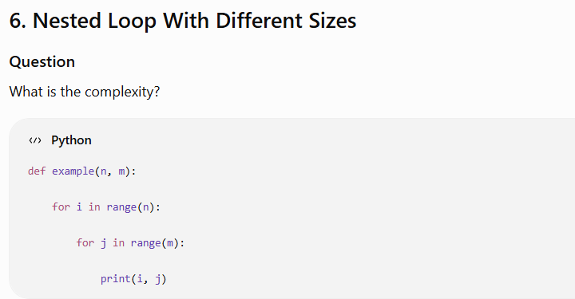
Notice that the loops don't both use n.
Outer loop:
n times
Inner loop:
m times
Therefore:
n × m
Time Complexity
O(n × m)
or:
O(nm)
Space Complexity
O(1)
Why isn't it O(n²)?
Because n and m are separate inputs.
For example:
n = 100
m = 1,000
Operations:
100 × 1,000
= 100,000
You cannot assume:
n = m
unless the question says so.
Final
Time = O(nm)
Space = O(1)

7. Create a New Array
Question
Create a copy of an array.
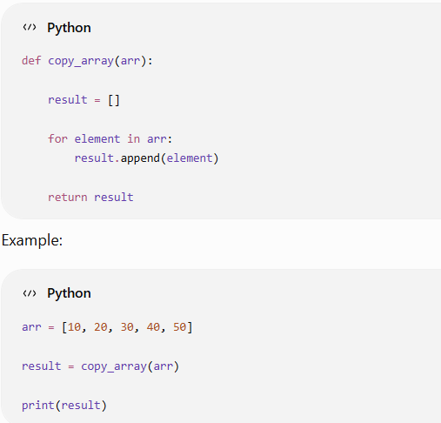

Output:
[10, 20, 30, 40, 50]
The loop runs:
n times
Therefore:
Time Complexity
O(n)
But now we are creating:
result = []
and storing all n elements.
Therefore:
Space Complexity
O(n)
Final
Time = O(n)
Space = O(n)
Important Difference
Compare this:
def print_elements(arr):
for x in arr:
print(x)
with:
def copy_array(arr):
result = []

for x in arr:
result.append(x)

return result
First:
Time = O(n)
Space = O(1)
Second:
Time = O(n)
Space = O(n)
The difference is additional memory.

8. Find the Maximum Element
Question
Find the largest number in an array.
def find_max(arr):

maximum = arr[0]

for i in range(1, len(arr)):

if arr[i] > maximum:
maximum = arr[i]

return maximum
Example:
arr = [10, 50, 20, 80, 30]

print(find_max(arr))
Output:
80
Dry Run
Initially:
maximum = 10
Check:
50 > 10
Yes:
maximum = 50
Next:
20 > 50
No.
Next:
80 > 50
Yes:
maximum = 80
Next:
30 > 80
No.
Final:
80
Regardless of where the maximum occurs, we need to inspect the array to know that it is the maximum.
Therefore:
Time Complexity
O(n)
Space Complexity
Only one variable:
maximum
So:
O(1)
Final
Time = O(n)
Space = O(1)

9. Loop That Doubles Each Time
Question
What is the complexity?
def example(n):

i = 1

while i < n:

print(i)

i = i * 2
This is a very important pattern.
Suppose:
n = 16
Values of i:
1
2
4
8
Next:
16
Now:
16 < 16
is false.
So the loop executes only:
4 times
Let's see larger n.
n = 2

1

n = 4

1 → 2

n = 8

1 → 2 → 4

n = 16

1 → 2 → 4 → 8

n = 32

1 → 2 → 4 → 8 → 16
The number of iterations is approximately:
log₂(n)
Therefore:
Time Complexity
O(log n)
Space Complexity
O(1)
Final
Time = O(log n)
Space = O(1)
Remember This Pattern
Whenever you see:
i = i * 2
or:
i = i // 2
you should immediately think:
O(log n)

10. Nested Loop With Increasing Range
Question
Find the complexity:
def example(n):

for i in range(n):

for j in range(i):

print(i, j)
This one is slightly more interesting.
Let's take:
n = 5
Outer loop:
i = 0
Inner loop:
0 times
Then:
i = 1
Inner loop:
1 time
Then:
i = 2
Inner loop:
2 times
Then:
i = 3
Inner loop:
3 times
Then:
i = 4
Inner loop:
4 times
Total:
0 + 1 + 2 + 3 + 4
This is:
n(n - 1) / 2
Expand it:
(n² - n) / 2
Ignoring constants and lower-order terms:
O(n²)
Time Complexity
O(n²)
Space Complexity
O(1)
Final
Time = O(n²)
Space = O(1)

Final 10-Question Summary
# | Pattern | Time | Space
1 | Single loop | O(n) | O(1)
2 | Array access | O(1) | O(1)
3 | Linear search | O(n) | O(1)
4 | Two sequential loops | O(n) | O(1)
5 | Nested loop | O(n²) | O(1)
6 | Nested n × m loop | O(nm) | O(1)
7 | Copy array | O(n) | O(n)
8 | Find maximum | O(n) | O(1)
9 | Doubling loop | O(log n) | O(1)
10 | Increasing nested loop | O(n²) | O(1)

The 7 Rules You Should Memorize
For your DSA preparation, these patterns are more important than memorizing individual answers.
Rule 1 — One loop
for i in range(n):
Usually:
O(n)

Rule 2 — Nested loops
for i in range(n):
for j in range(n):
Usually:
O(n²)

Rule 3 — Different inputs
for i in range(n):
for j in range(m):
O(nm)

Rule 4 — Sequential loops
for i in range(n):
...

for j in range(n):
...
O(n + n)
= O(2n)
= O(n)
Not O(n²).

Rule 5 — Multiplication/division loop
i = i * 2
or
i = i // 2
Usually:
O(log n)

Rule 6 — Creating another array
result = []

for x in arr:
result.append(x)
Usually:
Time = O(n)
Space = O(n)

Rule 7 — Ignore constants
O(2n) → O(n)
O(5n) → O(n)
O(100n) → O(n)

O(2n²) → O(n²)
O(10n²) → O(n²)
But don't ignore the dominant growth:
O(n² + n)
↓
O(n²)
O(n³ + n² + n)
↓
O(n³)

Your first DSA complexity target
Before moving into harder DSA, you should be able to look at code and immediately identify patterns like:
single loop → O(n)
nested loop → O(n²)
n × m loops → O(nm)
doubling/halving → O(log n)
loop + nested loop → usually O(n²)
new array of n elements → O(n) space
few variables → O(1) space
Once these become automatic, arrays, hashing, two pointers, sliding window, binary search, sorting, recursion, trees and graphs become much easier to analyze.

